Portfolio Segment 1 : Copies of Gulf Today features and other newspapers and news articles in online news platforms

- Gulf Today, English Newspaper, 19th November 2025, Page Number 19
- UAE News 24/7 Online (Website) – News Article in English Language
- UAE NEWS 247 – 2nd Report (Website) – News Article in English Language -
- UAE NEWS 247 – Facebook – News Article in English Language
- UAE NEWS 247 – Facebook – 2nd Report - – News Article in English Language –
- Gulf Today – Online News Article in English Language (Website) – 1
- Gulf Today Online (Website) – 2nd News Article in English Language
- Gulf Today Online – X.com – News Article in English Language
- Gulf Today – Facebook – 14th Novemeber 2025 - – News Article in English Language
- Gulf Today – Facebook – 19th Novemeber 2025 - – News Article in English Language
- Day of Dubai – Online (Website) – News Article in English Language
- Sharjah 24 – English News – Online (Website) – News Article in English Language
- Ain Alemirate –Online (Website) – News Article in English Language
- ALSAHAFA –Online – News Article in ARABIC LANGUAGE
- Gulf Suprabhatham, Malayalam Newspaper, 8th November 2025
- SirajNews Daily, Malayalam Newpaper, 8th November 2025
- Mathrubhumi, Malayalam Newspaper, 10th November 2025
- Manorama Online – Online (Website) – News article in Malayalam Language
- News Tag Live –Online (Website) – News article in Malayalam Language
- The Sharjah International Book Fair’s Official Malayalam Magazine, “Bookish” – featured “Aksharakkadalile Veliyettam” in the top most right corner, Page number 21
- The official PR agency of Sharjah Book Fair – NNC reported book name, author name and gist of information about the book “Aksharakkadalile Veliyettam” in their article about SIBF 2025

Sl. No. | Media / Publication | Details
1 | Gulf Today,  English Newspaper,  19th November 2025,  Page Number 19 | 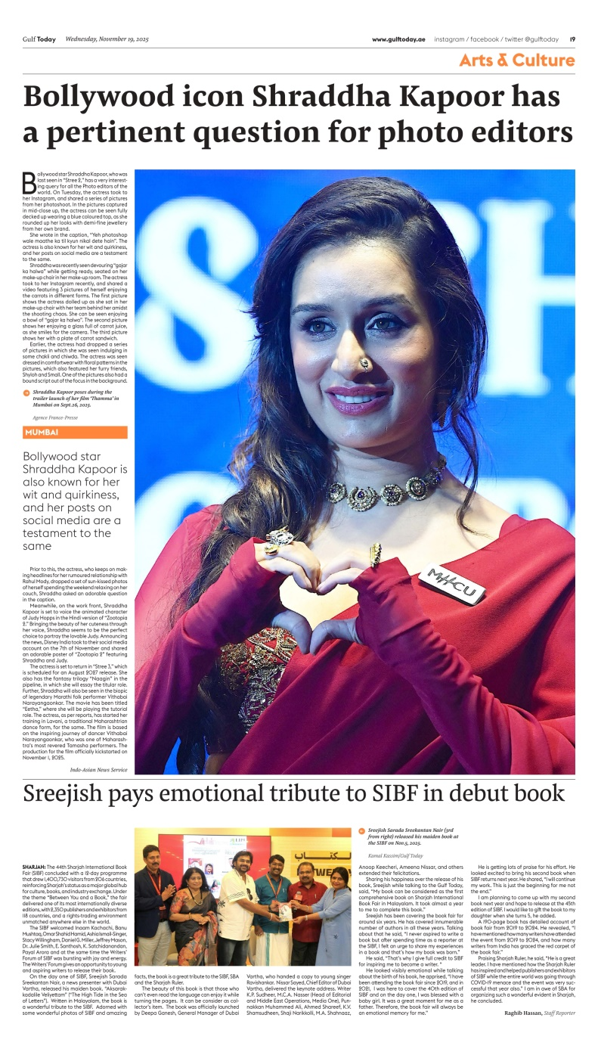
2 | UAE News 24/7 Online (Website) – News Article in English Language -  (link and QR Code is enclosed ) | https://uaenews247.com/2025/11/09/a-book-has-just-been-born-about-the-world-renowned-sharjah-international-book-fair-aksarakadalile-veliyettam-the-tide-in-the-ocean-of-letters/  
3 | UAE NEWS 247 – 2nd Report (Website) – News Article in English Language -  (link and QR Code is enclosed ) | https://uaenews247.com/2025/11/14/indias-literary-heartbeat-resonates-through-the-halls-of-sibf-2025/  
4 | UAE NEWS 247 – Facebook – News Article in English Language  (link and QR Code is enclosed ) | https://www.facebook.com/share/1AVSMx8sft/?mibextid=wwXIfr  
5 | UAE NEWS 247 – Facebook – 2nd Report - – News Article in English Language –  (link and QR Code is enclosed ) | https://www.facebook.com/share/1DpBXwj6Dj/?mibextid=wwXIfr  
6 | Gulf Today – Online News Article in English Language (Website) – 1  (link and QR Code is enclosed ) | https://www.gulftoday.ae/news/2025/11/12/sreejish-saradas-new-book-dives-deep-into-sharjahs-world-of-letters  
7 | Gulf Today Online (Website) – 2nd News Article in English Language - (link and QR Code is enclosed ) | https://www.gulftoday.ae/culture/2025/11/19/sreejish-pays-emotional-tribute-to-sibf-in-debut-book  
8 | Gulf Today Online – X.com – News Article in English Language - (link and QR Code is enclosed ) | https://x.com/gulftoday/status/1989255153938239844  
9 | Gulf Today – Facebook – 14th Novemeber 2025 - – News Article in English Language - (link and QR Code is enclosed ) | https://www.facebook.com/share/1DjHMvtZED/?mibextid=wwXIfr  
10 | Gulf Today – Facebook – 19th Novemeber 2025 - – News Article in English Language - (link and QR Code is enclosed ) | https://www.facebook.com/share/1CZufCEUxd/?mibextid=wwXIfr  
11 | Day of Dubai – Online (Website) – News Article in English Language - (link and QR Code is enclosed ) | https://dayofdubai.com/articles/aksarakadalile-veliyettam-a-new-book-inspired-by-the-sharjah-international-book-fair-launched-at-sibf-2025  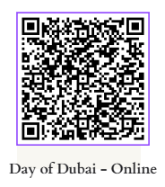
12 | Sharjah 24 – English News – Online (Website) – News Article in English Language - (link and QR Code is enclosed ) | https://share.google/zTaX1MmMzwGzgAsdV  
13 | Ain Alemirate –Online (Website) – News Article in English Language - (link and QR Code is enclosed ) | https://www.ainalemirate.com/en/2025/11/15/indias-literary-heartbeat-resonates-through-the-halls-of-sibf-2025/  
14 | ALSAHAFA –Online – News Article in ARABIC LANGUAGE - (link and QR Code is enclosed ) | https://alsahafa.org/show_news.php?id=2714  
15 | Gulf Suprabhatham, Malayalam Newspaper,  8th November 2025 | 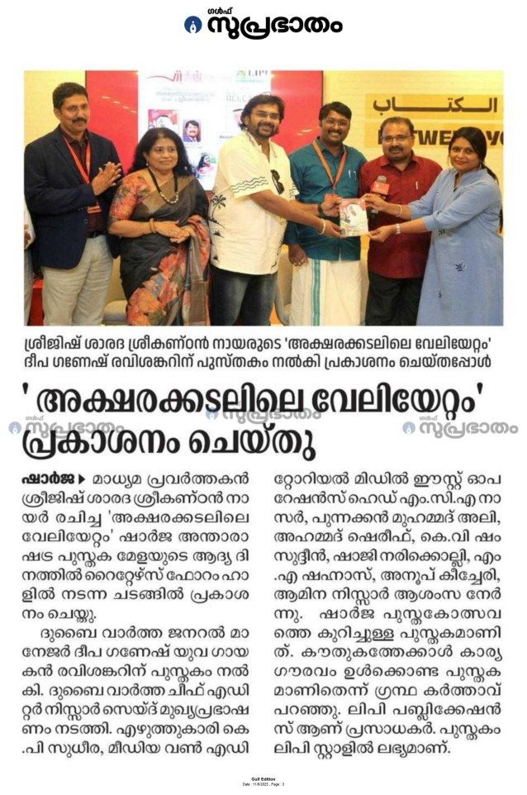
16 | SirajNews Daily, Malayalam Newpaper,  8th November 2025 | 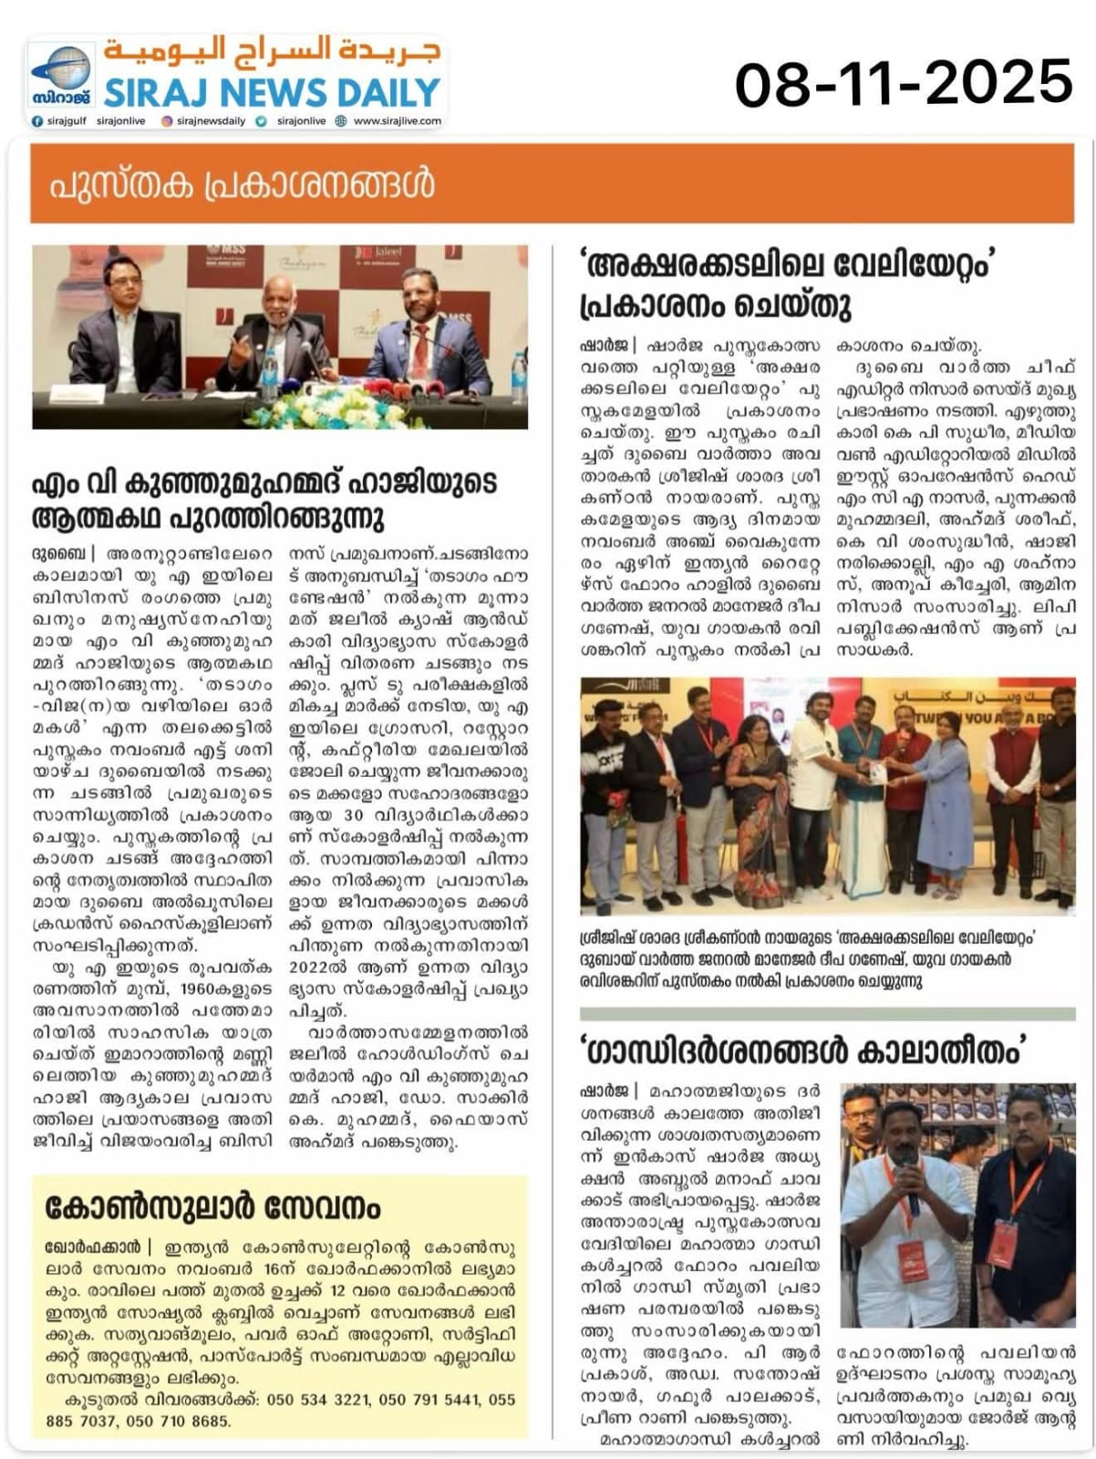
17 | Mathrubhumi,  Malayalam Newspaper,  10th November 2025 | 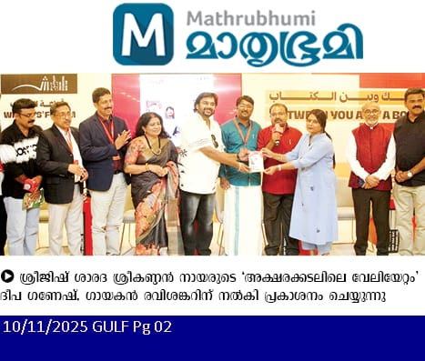
18 | Manorama Online – Online (Website) – News article in Malayalam Language  (link and QR Code is enclosed ) | https://www.manoramaonline.com/global-malayali/gulf/2025/11/08/sreejesh-nairs-book-launched-at-sharjah-book-fair.amp.html  
19 | News Tag Live –Online (Website) – News article in Malayalam Language - (link and QR Code is enclosed ) | https://newstaglive.com/aksharakadalile-veliyettam-book-released-at-sibf2025/  
20 | The Sharjah International Book Fair’s Official Malayalam Magazine, “Bookish” – featured “Aksharakkadalile Veliyettam” in the top most right corner, Page number 21  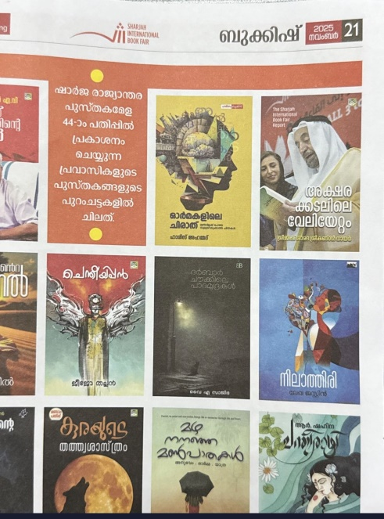 | 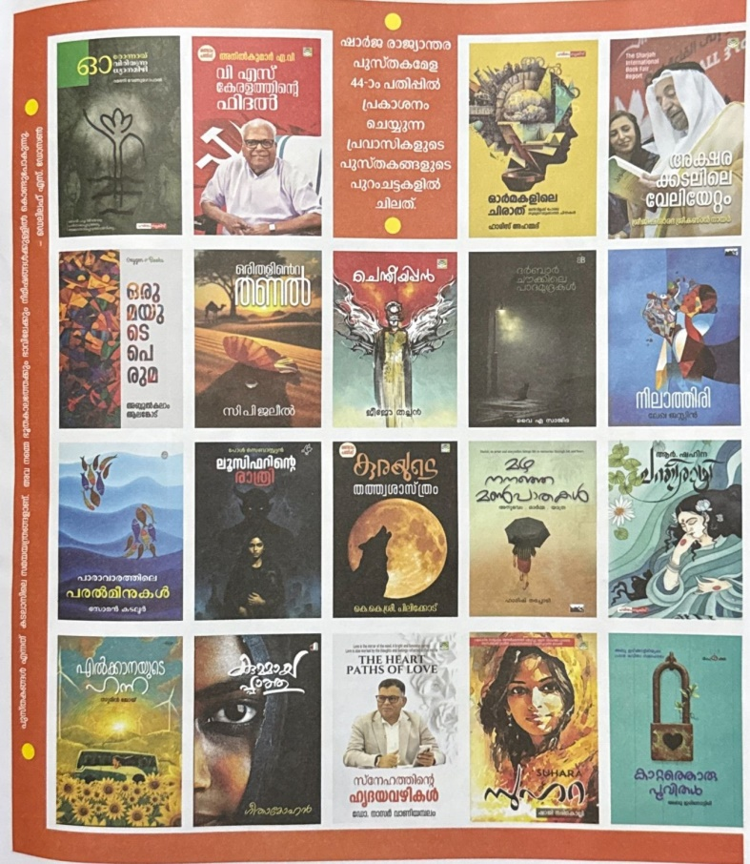
21 | The official PR agency of Sharjah Book Fair – NNC reported book name, author name and gist of information about the book “Aksharakkadalile Veliyettam” in their article about SIBF 2025  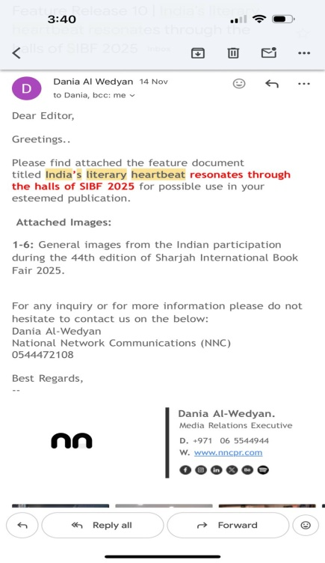 | 